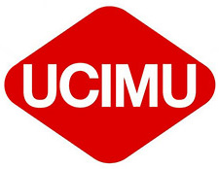


ECTA CONFERENCE IN ITALY
(20-22 MARCH 2025)

Name |  |  | Job Title
Company
Phone |  |  | e-mail

Based on the provisional information, we are

 | Interested in participating (to be confirmed when the full programme is published): |  |  |  | alone
 |  |  |  |  | with partner
 | Interested in the sponsorship programme

Date_________________________

Please return this to Alberto Nicolai, Marketing Manager, UCIMU-SISTEMI PER PRODURRE at marketing.dept@ucimu.it by Friday 12th July.

